ACSL
American Computer Science League
2006 - 2007

Contest #2

Junior Division

ACSL – The Next Generation
PROGRAM: Cellular Automata is a branch of mathematics that studies the effect of recursively applying a set of rules to a beginning state of cells in a grid. This area of study was made famous by John Horton Conway’s publication in 1970 of the Game of Life. In this program the grid will be one-dimensional. The beginning state of each cell as described by Conway is alive or dead. In the grid below, live cells are shaded and dead cells are white. Once the rules are applied to all the cells, a new grid is produced and is called the next generation. The beginning grid, its next two generations and the sample rules for the example given below are:
1. A cell will be alive in the next generation if a) the neighbor cell to its left is alive and the neighbor cell to its right is dead or b) the neighbor cell to its left is dead and the neighbor cell to is right is alive.
2. A cell will be dead in the next generation if a) the neighbor cell to its left is alive and the neighbor cell to its right is alive or b) the neighbor cell to its left is dead and the neighbor cell to is right is dead.
3. If there is no neighbor cell to the left or right of a cell, then consider those nonexistent cells to be dead.
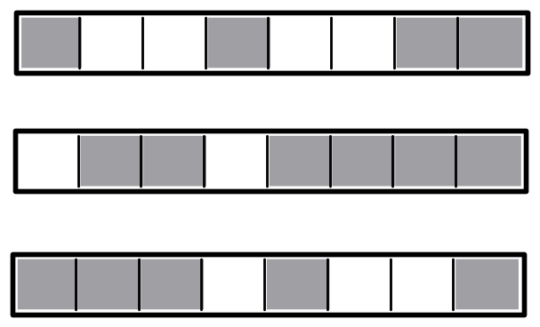

INPUT. There will be 5 lines of input. Each line will give the number of cells in the grid, the state of each cell in A or D format and the generation to output. For the example above the input is given on line #1.

OUTPUT: For each input line, print the state of the grid for the generation number given.

SAMPLE INPUT SAMPLE OUTPUT
- AAADADDA
- DAAD
- ADAAD
- AAADDA
- DADDAADA
- 8, A, D, D, A, D, D, A, A, 2
- 4, A, A, A, A, 2
- 5, A, D, D, A, D, 3
- 6, A, A, D, D, A, D, 4
- 8, D, A, A, D, D, A, D, D, 5

ACSL
American Computer Science League
2006 - 2007

Contest #2

Junior Division

ACSL – The Next Generation

TEST DATA

TEST INPUT TEST OUTPUT

1. 8, A, D, D, A, D, D, A, A, 3 1. ADADDAAD
2. 9, A, A, D, D, A, D, D, A, A, 4 2. AAAADAAAA
3. 10, A, A, D, D, A, D, D, A, A, D, 5 3. ADDADDADAD
4. 1, D, 6 4. D
5. 6, A, D, D, D, D, A, 6 5. AAAAAA

